**GitHub & GitHub Actions**

### 🚀 What is ****GitHub Actions****?

**GitHub Actions** is a **CI/CD (Continuous Integration and Continuous Deployment)** tool provided by GitHub that lets you **automate** tasks in your software development workflow — **directly in your GitHub repository**.

Create an account on GitHub:- <https://github.com/>

Create new repository :- Terraform-code

Organization requirement is to create a storage account code on GitHub (remote repository) then what will be the steps:-

1. We will access the ticket.
2. Clone the repo from remote to local (Git clone <https://github.com/getsumantra/Terraform-code.git>)
3. Create a feature branch
4. Write the storage account code in feature branch.
5. Git status
6. Git add **.**
7. Git commit -m “storage account code”
8. Git push
9. Raise pull request – feature branch to main and put reviewer

### ⚔️ What is a ****Git Conflict****?

A **Git conflict** happens when **two or more people** (or branches) have made **changes to the same part of the same file**, and Git doesn't know **which change to keep** during a **merge or rebase**.

Steps for pushing a storage account code from local to remote repository.

* Create a remote repository and copy its hyperlink
* Open vs code and clone it using (git clone https://github.com/getsumantra/Terraform-code.git)
* Create a feature branch using (git branch feature/storage)
* To check which branch is selected (git branch)
* To switch or directly create feature branch (git checkout -b feateure/storage)
* Create a storage account code inside VScode
* Add. gitignore file and add all file which you won’t push like (.terraform, lock.hcl, .exe file)
* Git status
* Git add main.tf (to add one file in staging area)
* Git add **.** (to copy complete file in staging area)
* Git commit -m “add_storage_account”
* Git push (but due to applied policies on main branch code could note be pushed on the main)
* git push --set-upstream origin feature/storage
* Now code has been pushed to repository on feature branch select this and raise a PR
* Raise PR (pull request) and add reviewer
* After the approval of reviewer code will be merged from the feature branch to main branch.

Steps for pushing a todoapp infra code from local to remote repository by raising a Pull Request…

* Create a remote repository and copy its hyperlink
* Open vs code and clone it using (git clone https://github.com/getsumantra/Terraform-code.git)
* Create a feature branch using (git branch feature/Jira-101-new-resources)
* To check which branch is selected (git branch)
* To switch or directly create feature branch (git checkout -b feature/ Jira-101-new-resources)
* Create a VM code using modules approach code inside VScode
* Add. gitignore file and add all file which you won’t push like (. terraform, lock.hcl, .exe file)
* Git status

Now we need to setup a policy to remote repository so that any can’t add the code directly to our main branch

* <https://github.com/getsumantra/testing> go to repository first where you want to set policy
* Repo >> Setting >> collaborator >> add people >> add person email id which will be approve all PR
* Repo >> setting >> Branches >> add classic branch protection rule
* Check on box :- Require a pull request before merging >> add at least 1 approver
* Go to VS code and do it
* Git add **.**
* Git commit -m “code added”
* Git push (but due to applied policies on main branch code could note be pushed on the main)
* git push --set-upstream origin feature/storage
* Now code has been pushed to repository on feature branch select this and raise a PR
* Raise PR (pull request) and add reviewer
* After the approval of reviewer code will be merged from the feature branch to main branch.

Now policy has become set lets and code pushed in feature branch now raise a Pull Request (PR):

* [getsumantra](https://github.com/getsumantra) / [testing](https://github.com/getsumantra/testing) (go to repo) >> pull request >> New pull request >> add one approver >> add comment and submit
* Email has sent to approver email id open that link and check and approve the required changes

Now the code has become merged to the main branch and changes will be shown here

**Git conflict **

A **Git conflict** happens when **two or more people** (or branches) have made **changes to the same part of the same file**, and Git doesn't know **which change to keep** during a **merge or rebase.**

How conflict will be created if I’m using my own laptop and no teammates is there….?

Requirements:

* Create two feature branch and change the code and commit in both branches and push it one by one.
* And raise PR request then one conflicts will be shown during approval time.

Steps to create the repository & clone it on local:

* Create a remote repository and copy its hyperlink
* Open vs code and clone it using (git clone <https://github.com/getsumantra/Terraform-code.git>)
* For the first time create a code and push to GitHub repo.

Steps to create the two-feature branches & How conflicts arise:

* git checkout -b feature/101-Jira-RG >> Create and select a new branch
* git checkout -b feature/102-Jira-Vnet >> Create and select a new branch
* git checkout feature/101-Jira-RG >> Select branch
* git add .
* git commit -m “one_rg_added”
* git push >> error
* git push - -set-upstream origin feature/101-Jira-RG

Raise a PR for branch feature/101-Jira-RG, after approval code will be merged to the main branch

But from the second feature branch if we are pushing any code which doesn’t have the previous commit the it will create a conflict.

For eg: - if feature branch tirju has 6 commits and birju branch doesn’t have 6th commit details then conflict will come up on branch tirju.

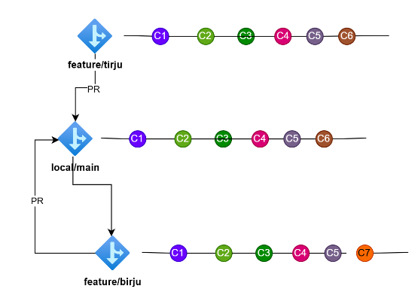

How to resolve this git conflicts: -

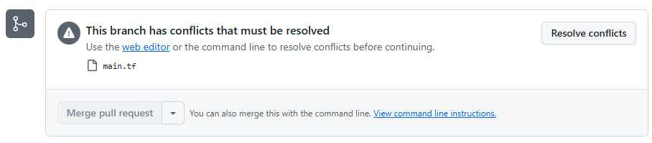

Option 1. Got to inside resolve conflicts option and this window will appear and remove not required codes and merge it

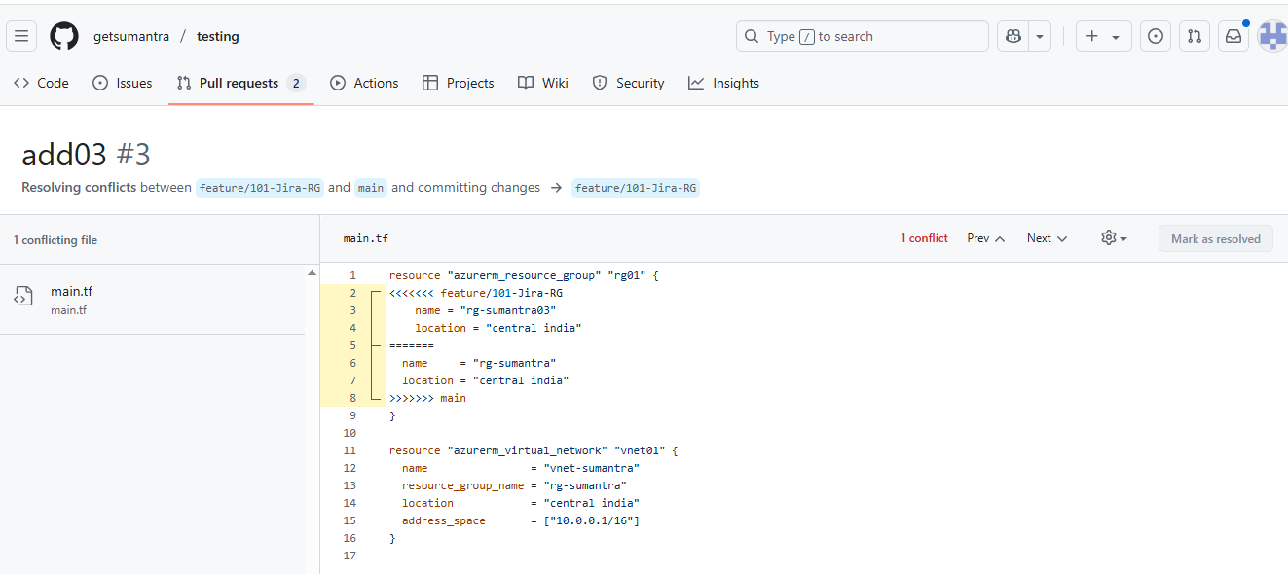

Option 2.

* Select branch which having the conflict git checkout feature/101-Jira-RG
* git pull origin main

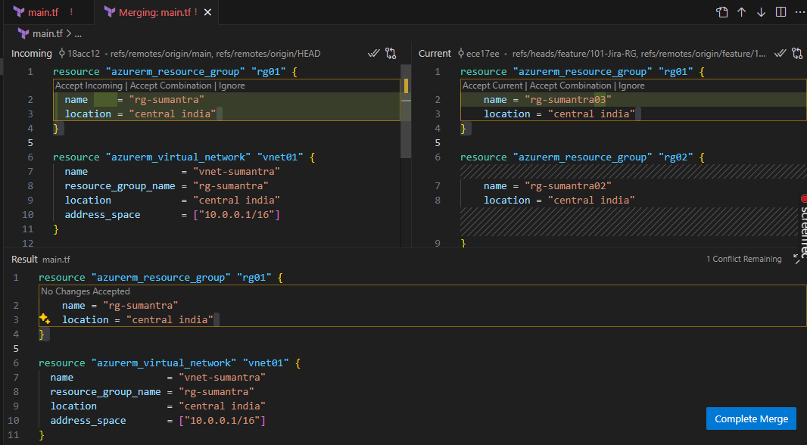

Isme se kaun sa code rkhna hai usko rkh lenge aur complete merge wale option pr click kr denge

Then again PR approve kr ke merge kr denge, Result main.tf will be the final commit.

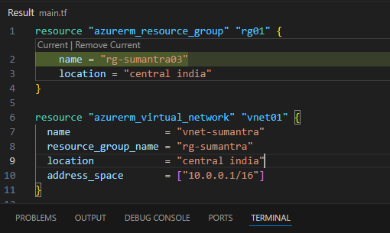

Security tools for the Infrastructure scanning

For the infrastructure we can use multiple tools mostly tools are CLI based so for this we need to visit their GitHub repository.

1. **Tfsec**

* <google search> tfsec github >> <https://github.com/aquasecurity/tfsec>

Go to the Releases option >> drag down and select version >> [tfsec-windows-amd64.exe](https://github.com/aquasecurity/tfsec/releases/download/v1.28.14/tfsec-windows-amd64.exe) >> download this

* Rename this file as >> tfsec >> copy and create a folder in C drive and paste it copy that folder path and set it environment variables >> path set
* Open VS code and type >> tfsec –version (if version is appearing then its okay)

1. **Tflint**

* <google search> tflint github >> <https://github.com/terraform-linters/tflint>

Go to that Releases option >> drag down and select version >> [tflint_windows_amd64.zip](https://github.com/terraform-linters/tflint/releases/download/v0.58.1/tflint_windows_amd64.zip) >> download this

* Rename this file as >> tfsec >> copy and create a folder in C drive and paste it copy that folder path and set it environment variables >> path set (or paste directly into the tfsec folder then no need to set environment variables)
* Open VS code and type >> tflint –version (if version is appearing then it’s okay)

We can follow same process for each security tools

1. **Checkov**
2. **Balckduck**
3. **Terrascan**
4. **Trivy**
5. **Snyk IaC**
6. **Prisma Cloud**

Security tools for the applications

Type of application security tools

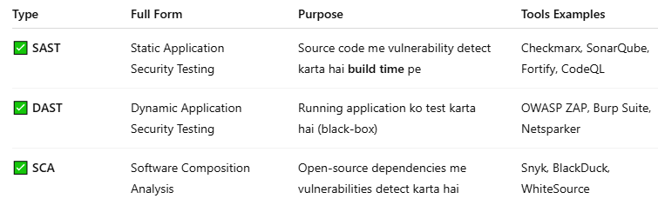

1. **SonarQube**
2. **BlackDuck** (SCA - OSS License + Vuln)
3. **Aqua**
4. **Trivy**
5. **Checkmarx** (SAST)
6. **Snyk (Code + SCA)**
7. **OWASP ZAP** (DAST)
8. **Burp Suite** (DAST)

Azure Devops

Github actions

Azure Devops

UI Based

YAML Based

Classic Pipeline Using Azure Devops

<https://aex.dev.azure.com/> >> Login >> set organization >> create project

Go to the organization level setting >> Pipelines >> setting >> and enable two option below

Off >> **Disable creation of classic build pipelines**

Off >> **Disable creation of classic release pipelines**

Select Project >> Pipelines >> Releases >> New pipeline (this the classic pipeline UI based)

Stages >> + add >> new stage >> Empty job >> Stage name >> Stage1 (type) >> save

Stage1 >> 1 Job o task select >> Agent job + select >> search Azure cli (add) >> Select Azure cli

Display name >> RG added >> Azure resource manager connection: Drag down and select (service connection) which you have already made >> Script type: Shell >> script location: Inline script

Inline script: az group create –name RG-Sumantra –location centralindia >>>> Save

Create release >>

Now pipeline will RUN and resource get provisioned